**MATHEMATICS SPECIALIST 3 & 4** Name_________________

**Test 2 2018**

**Section One: Calculator Free**

Reading Time: 2 minutes

Time Allowed: 28 minutes Total Marks: 26

**Question 1 (9 marks)**

Give exact expressions for each of the following in the form a + bi.

(a) $\frac{3}{2i}$ $+2i$. (2 marks)

(a) 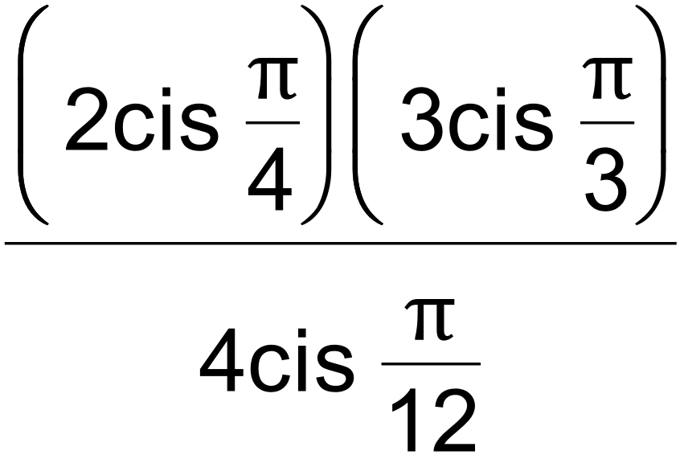 (2 marks)

(b) 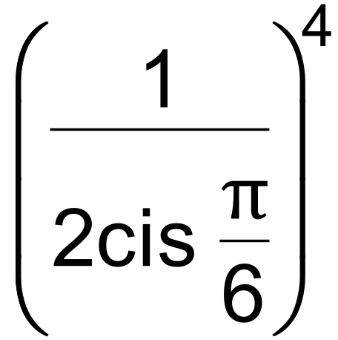 (2 marks)

(c) 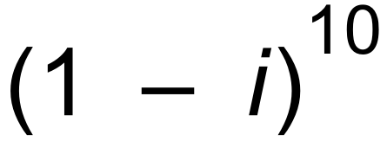 (3 marks)

**Question 2 (4 marks)**

Consider 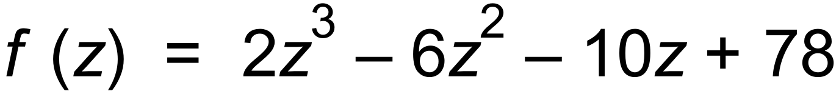.

Solve 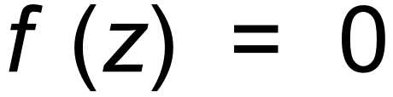, if we know that f (−3) = 0. (4 marks)

**Question 3 (4 marks)**

State a symbolic description for the set of points indicated by the shaded region on the graph drawn below.

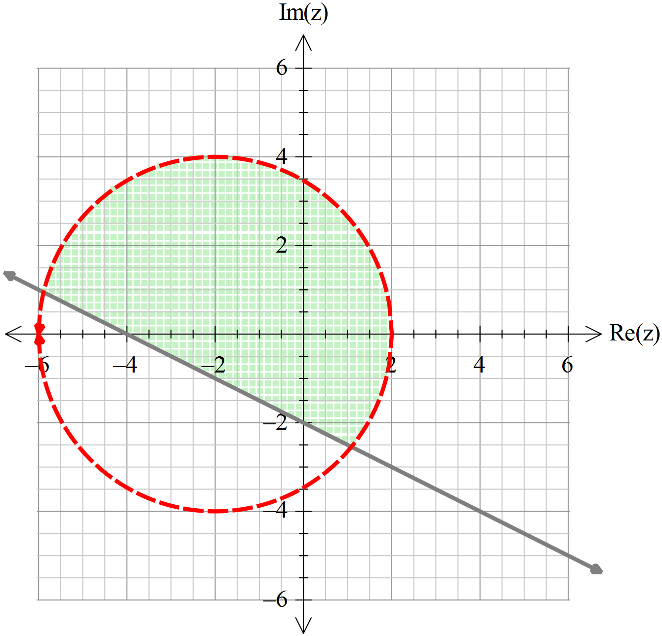

**Question 4 (5 marks)**

Determine the 5th roots of  and plot them on the Argand plane provided below.

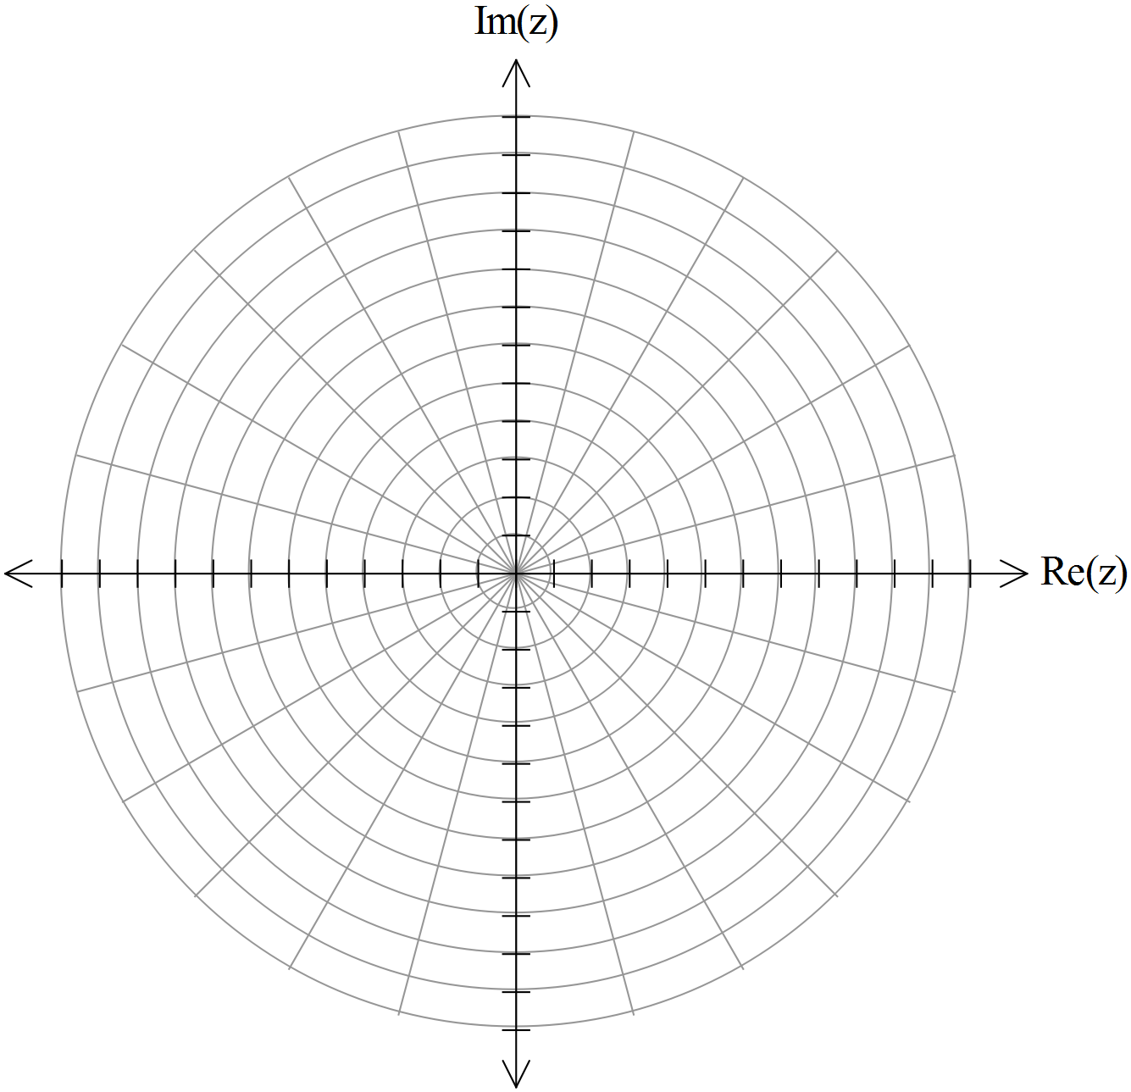

**End of Questions**

**Question 5 (4 marks)**

Let $z=a+bi where a >0, b>0 and a≠b.$ Consider $w=z-i\overline{z}$.

Determine the possible value(s) for $arg⁡(w)$.

**MATHEMATICS SPECIALIST 3 & 4** Name_________________

**Test 2 2018**

**Section One: Calculator Assumed**

Reading Time: 2 minutes

Time Allowed: 35 minutes Total Marks: 33

**Question 6 (6 marks)**

The complex numbers $v$ and $w$ are shown on the Argand diagram below.

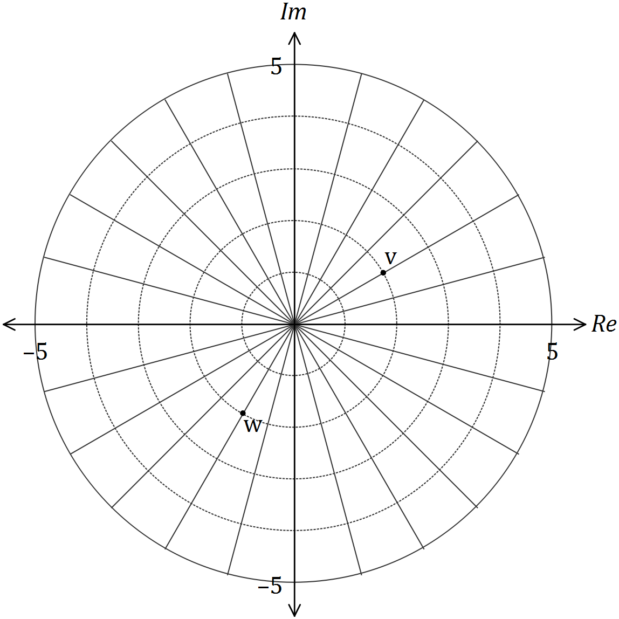

On the diagram, clearly mark the complex numbers

(a) $z_{1}=vw$. (2 marks)

(b) $z_{2}=$ $\frac{v}{w}$. (2 marks)

(c) $z_{3}=v-iw$. (2 marks)

**Question 7 (8 marks)**

On the axes below sketch the locus of the complex number z = x + yi, given by:

(a) | z + 1 − 2i | ≤ 1 and | z + i | ≥ | z − (2 + i) | . (4 marks)

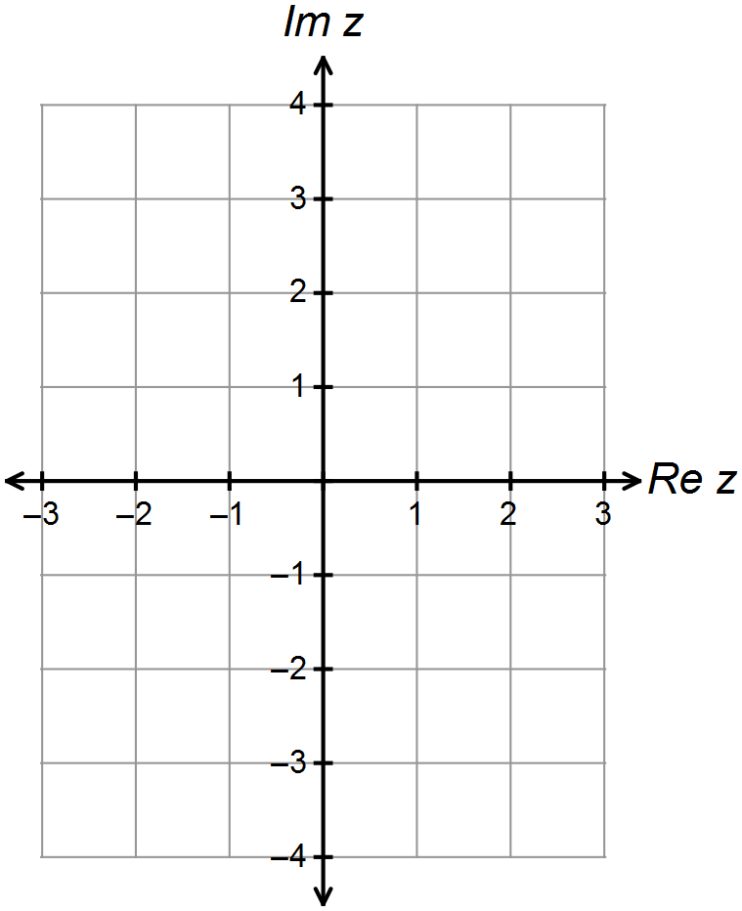

(b) 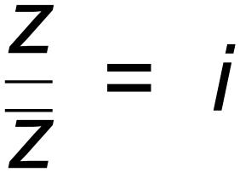 . (2 marks)

(c) Given that a = 1 + 2i and b = 3 + 4i, sketch on the complex plane below;

{ z : | z − a | + | z − b | = | a − b | }. (2 marks)

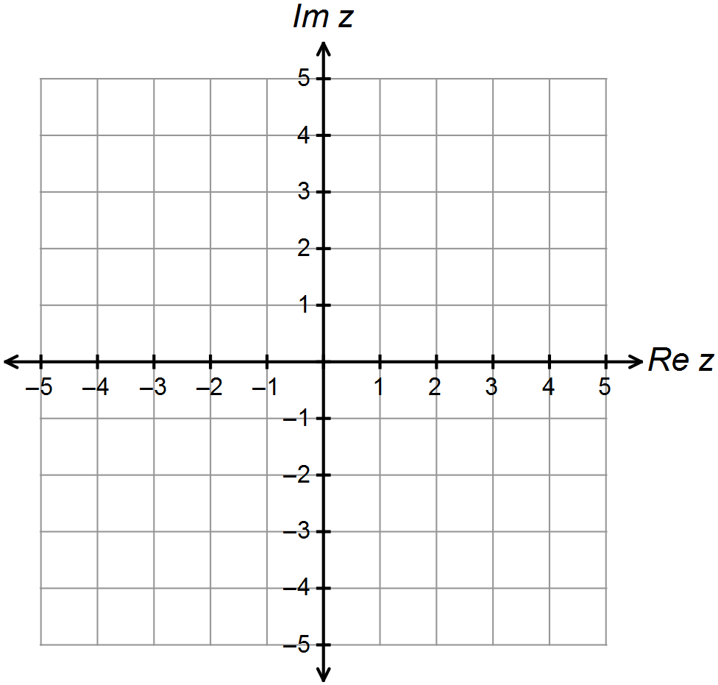

**Question 8 (5 marks)**

The subset of the complex plane, z, is a circle with centre $O$ shown below.

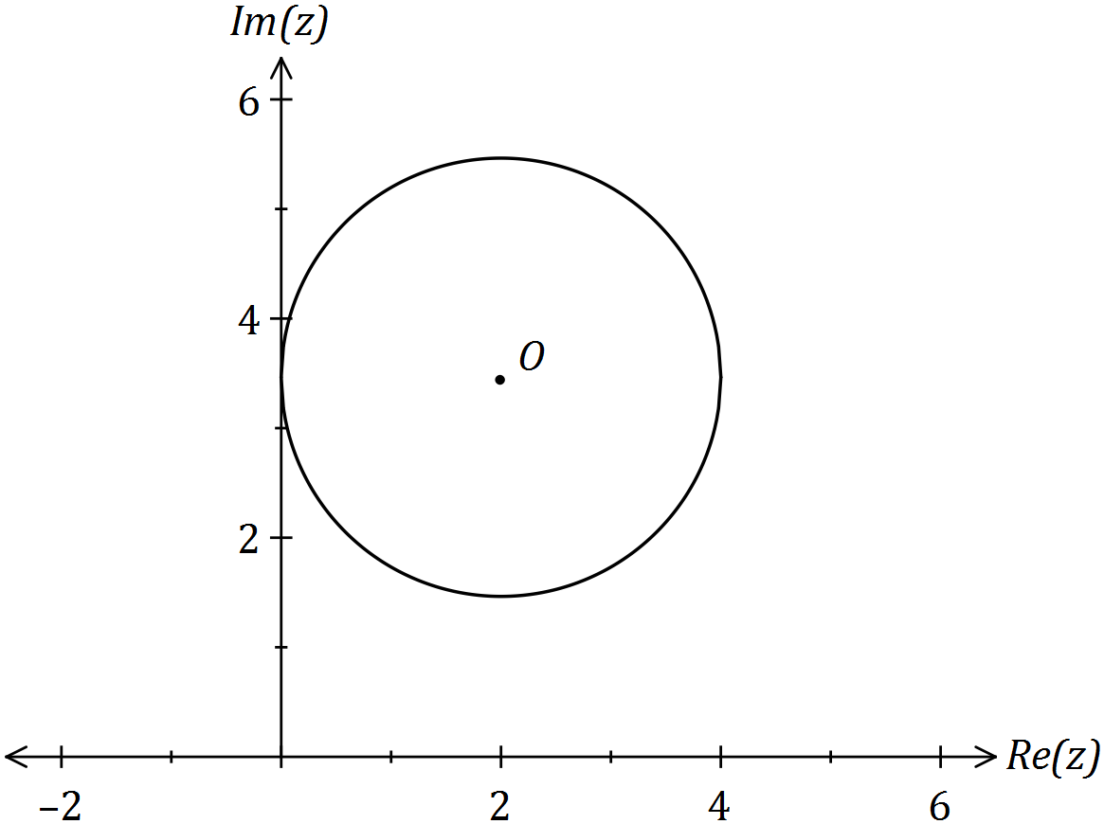

(i) Mark the position in the plane where $\left|z\right|$ is maximised. Label this point (i).

(1 mark)

(ii) Mark the position in the plane where $\left|z-2\right|$ is minimised. Label this point (ii).

(1 mark)

(iii) If the subset shown is $\left|z-2-2\sqrt{3}i\right|=2$, determine the maximum and minimum values of $\arg{z}$. (3 marks)

**Question 9 (8 marks)**

Consider the complex number $z=\operatorname{cis}{θ}$ and the expansion of $z^{n}={\left(\cos{θ}+i\sin{θ}\right)}^{n}$.

(a) Use De Moivre’s theorem to express $\cos\left(4θ\right)$ in terms of $\cos{θ}$. (5 marks)

(b) Use your result in (a) to solve the equation $8x^{4}-8x^{2}+1=0$. (3 marks)

**Question 10 (6 marks)**

Given  , determine .